ICIN BANK APPLICATION

# **CAPSTONE PROJECT**

## **ProJECT DOCUMENTATION**

**TEAM NO. - 3**

**TEAM MEMBERS**

| SNO | NAME OF TEAM MEMBERS | EMAIL ID |
| --- | --- | --- |
| 1. | Bhavani.S | [bhavani290399@gmail.com](mailto:bhavani290399@gmail.com) |
| 2. | Gomathi.S | [ucs16122@rmd.ac.in](mailto:ucs16122@rmd.ac.in) |
| 3. | Pooja Ravikumar | [ravikumarpooja1998@gmail.com](mailto:ravikumarpooja1998@gmail.com) |
| 4. | Prasad.N | [prasadnithi15@gmail.com](mailto:prasadnithi15@gmail.com) |
| 5. | Sarvin.SS | [sarv16319.cs@rmkec.ac.in](mailto:sarv16319.cs@rmkec.ac.in) |
| 6. | Sherley Swetha.JS | [sherleyshewetha.20it@licet.ac.in](mailto:sherleyshewetha.20it@licet.ac.in) |
| 7. | Vattigunta Revanth Kumar Reddy | [ucs16331@rmd.ac.in](mailto:ucs16331@rmd.ac.in) |

### **ProjecT OBJECTIVE**

Create a dynamic and responsive Java online banking web application to deposit, withdraw, and transfer money between accounts.

**PROBLEM STATEMENT**

ICIN is one of the top banking firms that accepts deposits from the public for the purpose of lending loans to the public. It also invests an amount in securities. Recently, the business analysts noticed a drop in the number of customers of the bank. They found out that online banking systems of banks like AXIS and American Express are gaining more profits by eliminating middlemen from the equation. As a result, the team decided to hire a Full Stack developer who can develop an online banking web application with a rich and user-friendly interface.

## **SOURCE CODE**

**LINK** - <https://github.com/prasad-ops/finalcapstoneproject>

* Download the source file from the above github link on your system.
* This project has two portals,
  + - * User portal - localhost:8080/index
      * Admin Portal – localhost:4200
* First, execute the User portal as Spring boot Application.

## **USER PORTAL**

User-Front is a user-facing system and it includes modules such as,

* User Signup/Login
* Account
* Transfer
* Request Cheque Book
* Transaction and User Profile

**KEY FUNCTIONALITIES IMPLEMENTED IN USER PORTAL-ICIN BANK**

* Register or log in to the application to maintain a record of activities
* Deposit and withdraw money from the account
* View the balance in their primary and savings account
* transfer funds between different accounts and add recipients
* Cheque book requests for different accounts

**USER PORTAL EXCECUTION**

* Please ensure that the following tools are installed in your system:

1. Java 1.8 and above
2. Eclipse IDE
3. Tomcat 8 and above
4. MySQL 8.0
5. Spring Boot
6. Hibernate
7. HTML/CSS

**Step 1 :** Importing up the project files in the Eclipse IDE.

* Download the **ICINBank-userfront.zip** file and extract it.
* Open Eclipse IDE, go to **File->Open Projects from File System,** and select the directorywhere you have saved the extracted file

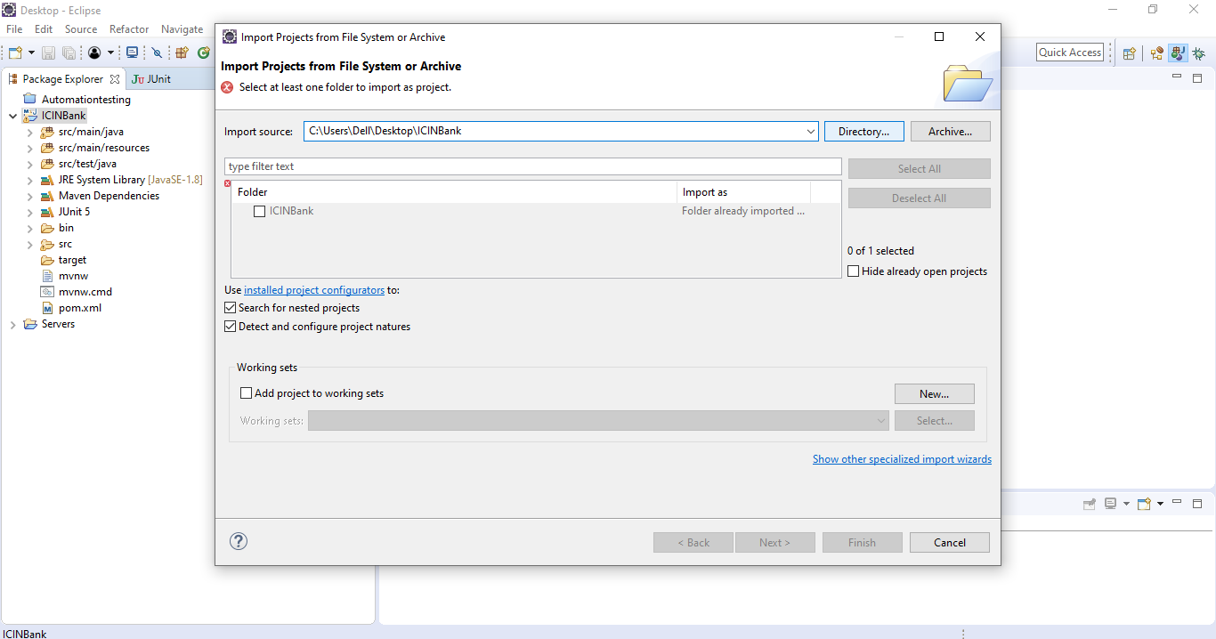

**Step 2:**

* Once the project is updated, right-click on the project and go to **Run as > Spring Boot App**

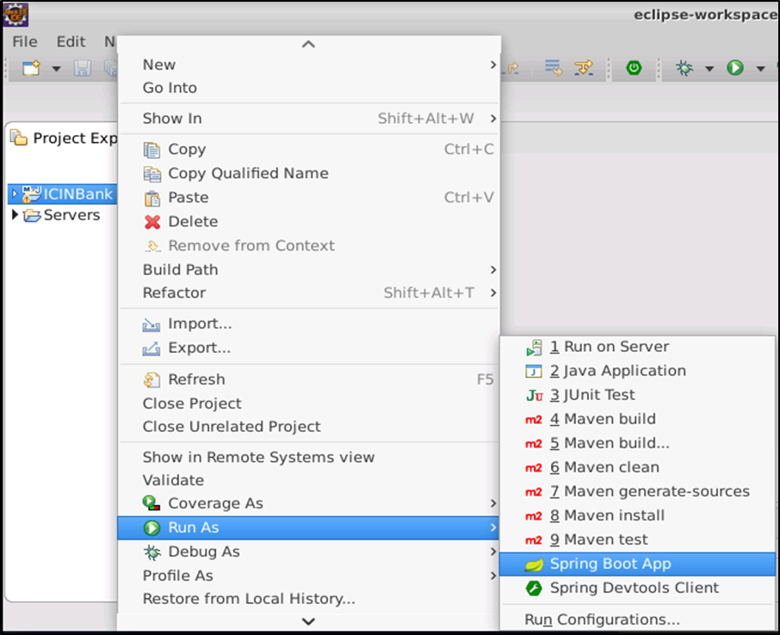

**Step 3**: case MySQL server is inactive, run the following command to start the server

* Run the following command to use MySQL as root user and enter the password for root user:

***sudo mysql -u root –p***

* Use the following command to create the icinbank database in MySQL:
* *>****create database icinBank;*** 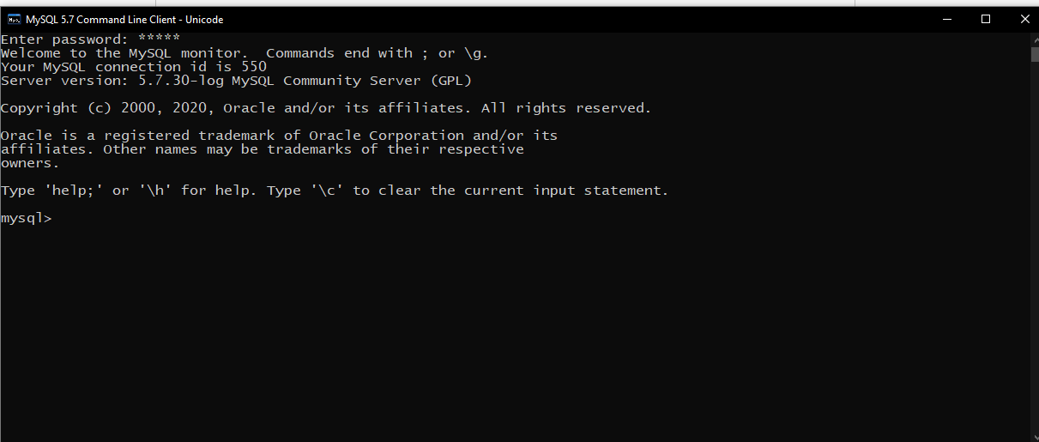
* Open the **application.properties** file in the ICIN Bank project and update the root user password
* While running the application, hibernate will create the tables in the database. Use the following command to check the tables:

***> use icinbank;***

*> show tables; 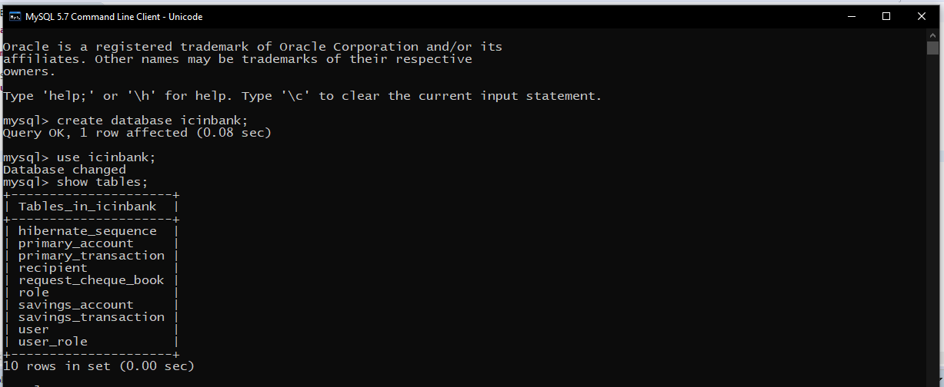*

* In the role table, set the role id and name for User and Admin role as shown below in MSQL Workbench.
* ***insert into role (id, name) values (0, ‘ROLE_USER’);***
* ***insert into role (id, name) values (1, ‘ROLE_ADMIN’);***

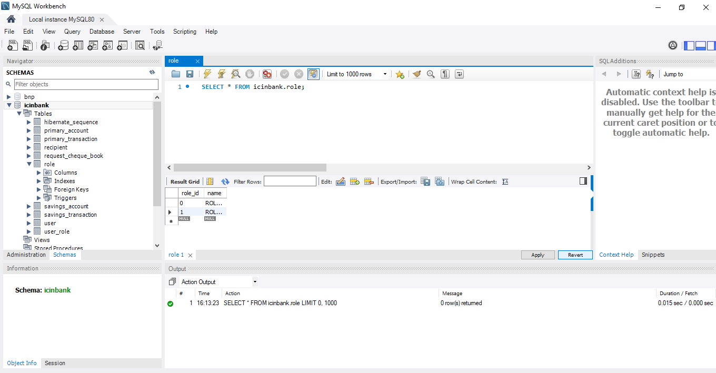

**User login**

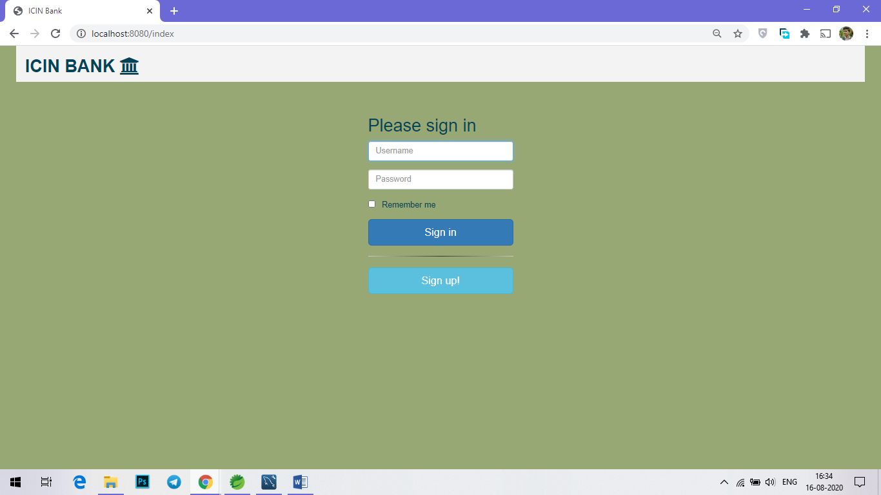

**User signup**

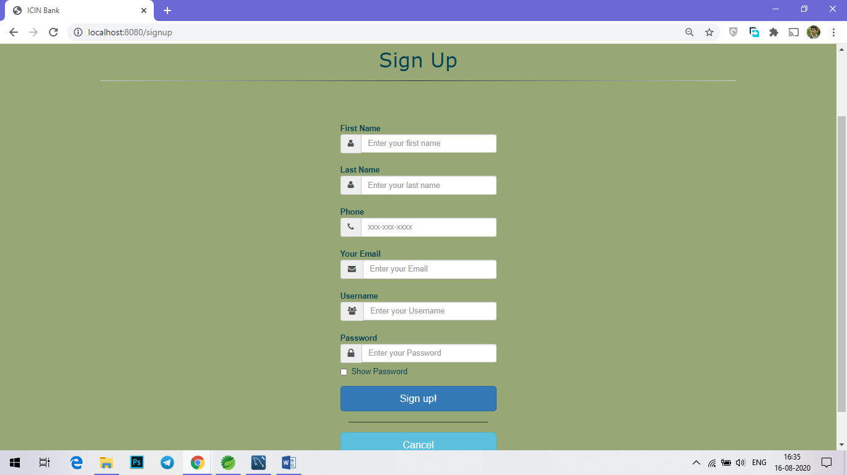

**Homepage**

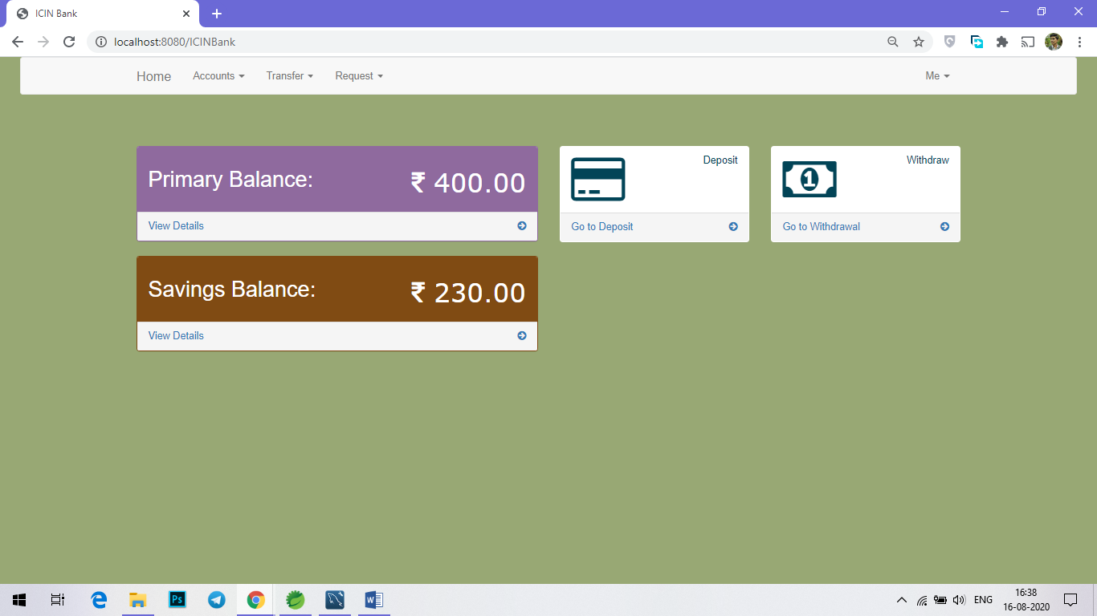

**Primary account**

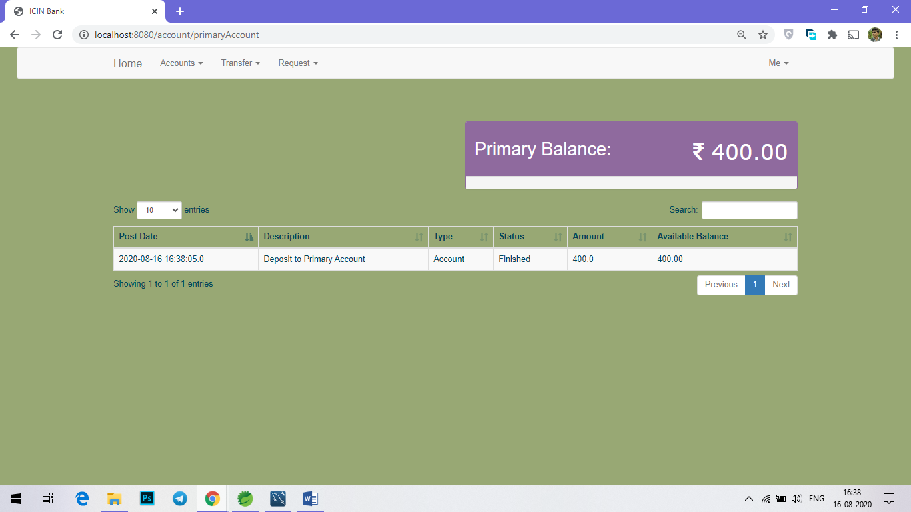

**Savings account**

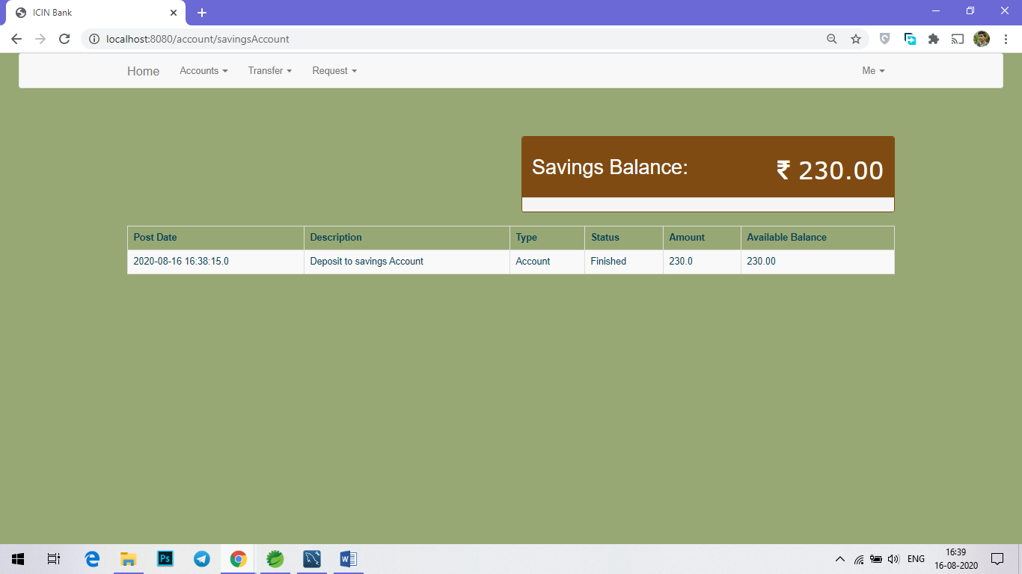

Deposit

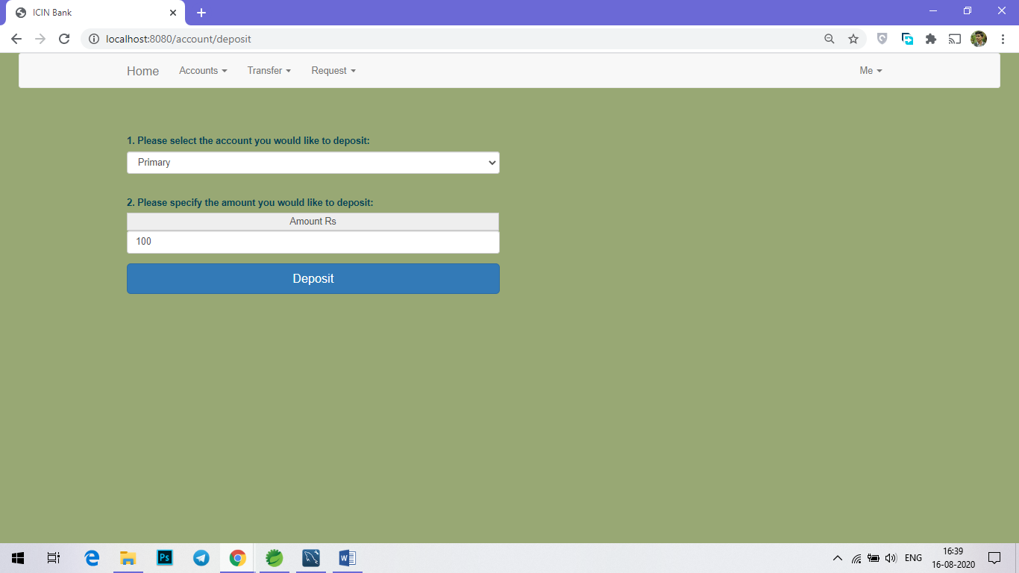

**Withdraw**

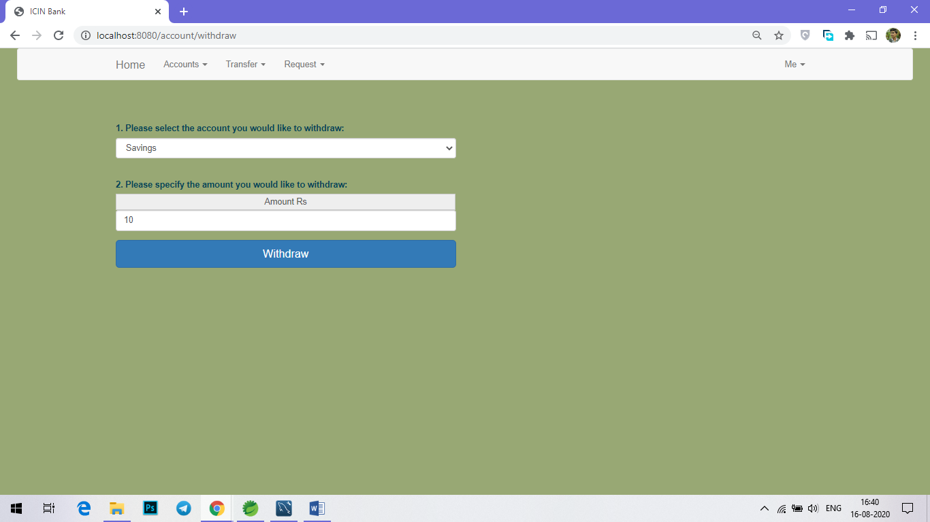

**Add recipient**

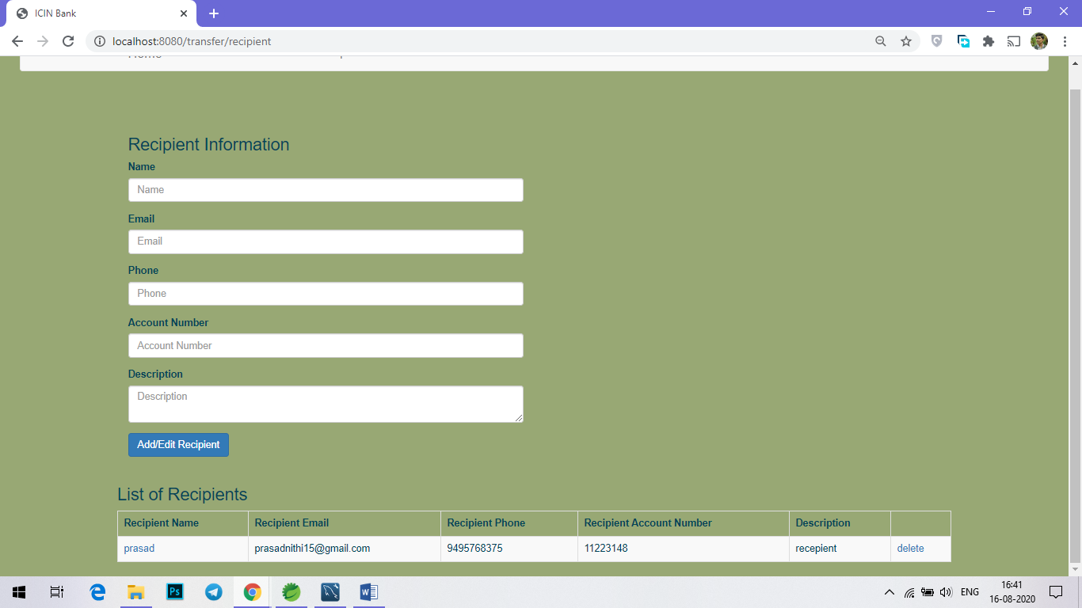

**Transfer**

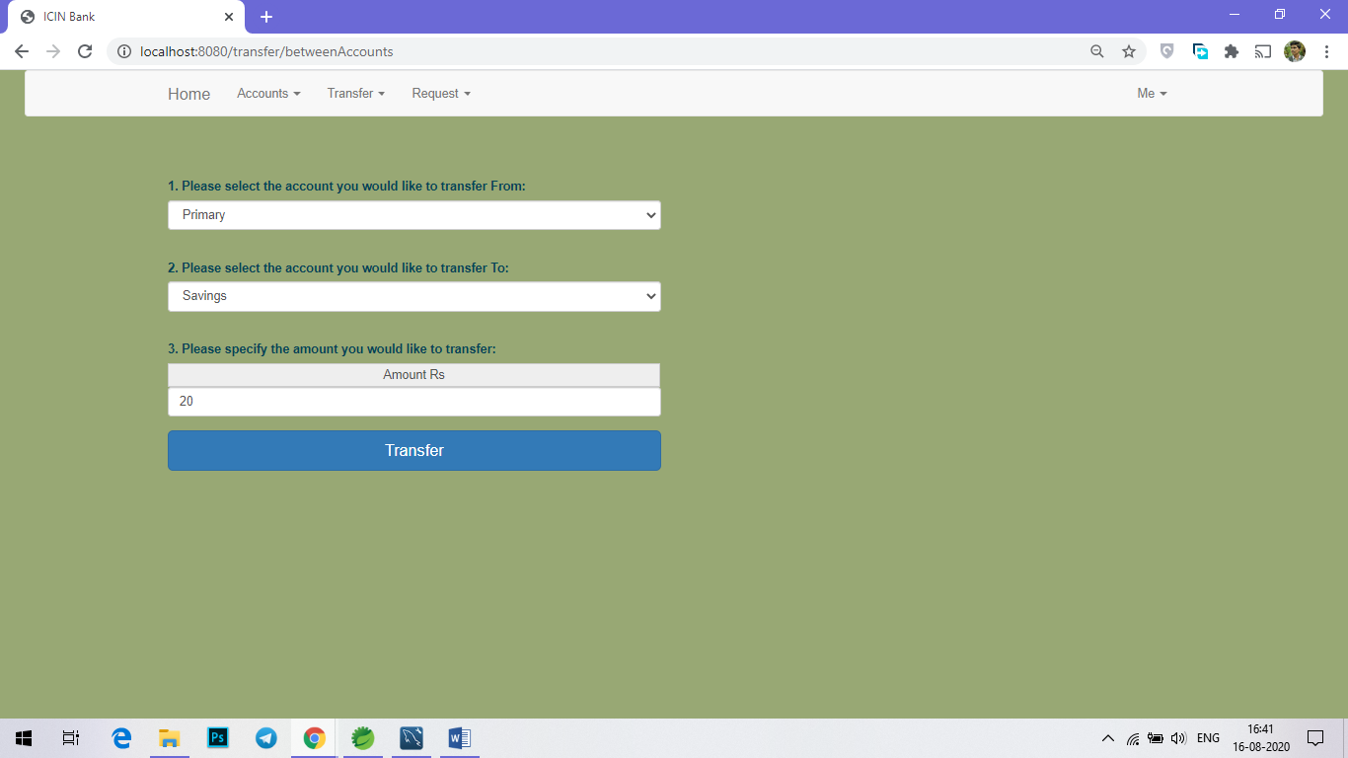

**Request checkbook**

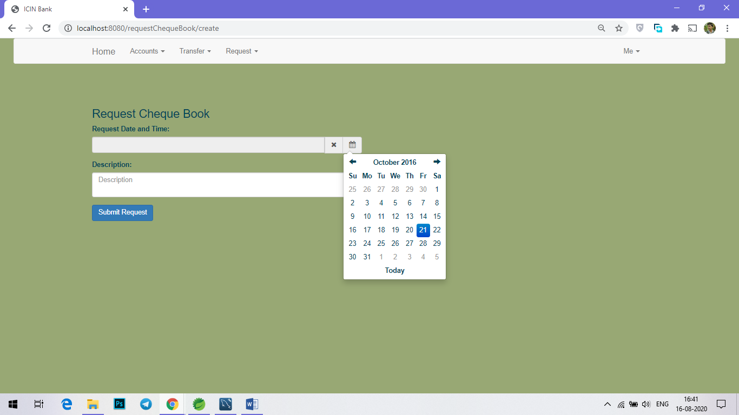

**Profile**

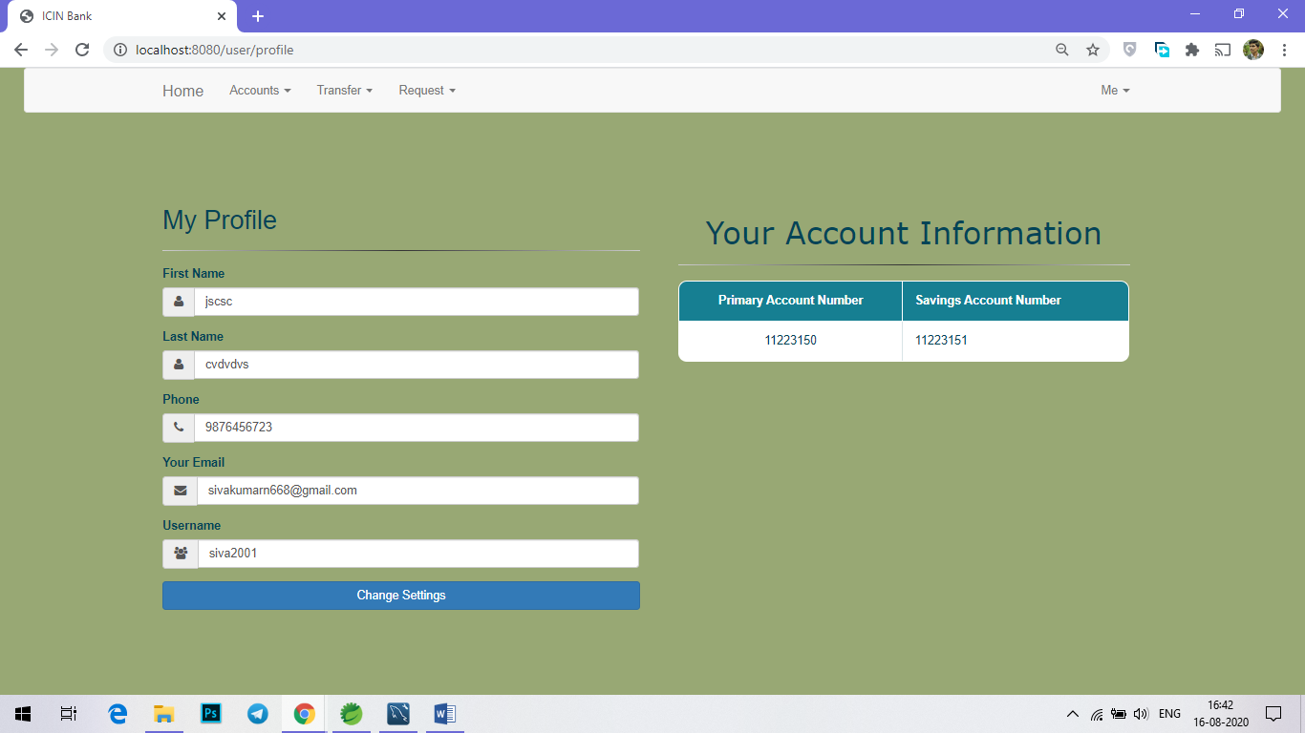

**ADMIN PORTAL**

**Requirements:**

* Angular 6 and above
* Node Installation
* Visual studio code – for writing angular codes ( text editor )

**Admin Portal – Key Functionalities**

* It is mainly used by Admin.
* it involves,
  + 1. User Account module
    2. Request Confirmation module.

Admin can enable/disable Users, view statements of every Users, confirm an User Request.

* Authorize the roles and guidelines for the user.
* Grant access to the user regarding money transfer, deposits, and withdrawal.
* Block a user account in case of any threat and authorize cheque book requests

**ADMIN PORTAL EXCECUTION**

**Step 1:** Download the zip file of the AdminPortal and extract it

**Step 2:** Type **cd AdminPortal** to navigate to the folder location

**Step 3:** Type *ng serve* to execute the project

In case of an error message: **Cannot find module 'rxjs-compat/Observable,'** execute the following commands to fix the issue**:**

***> npm install --save rxjs-compat  
> npm audit fix***

* Now execute the ***ng serve*** command to launch the application.

**Admin Login:** authorized admin can access this portal.

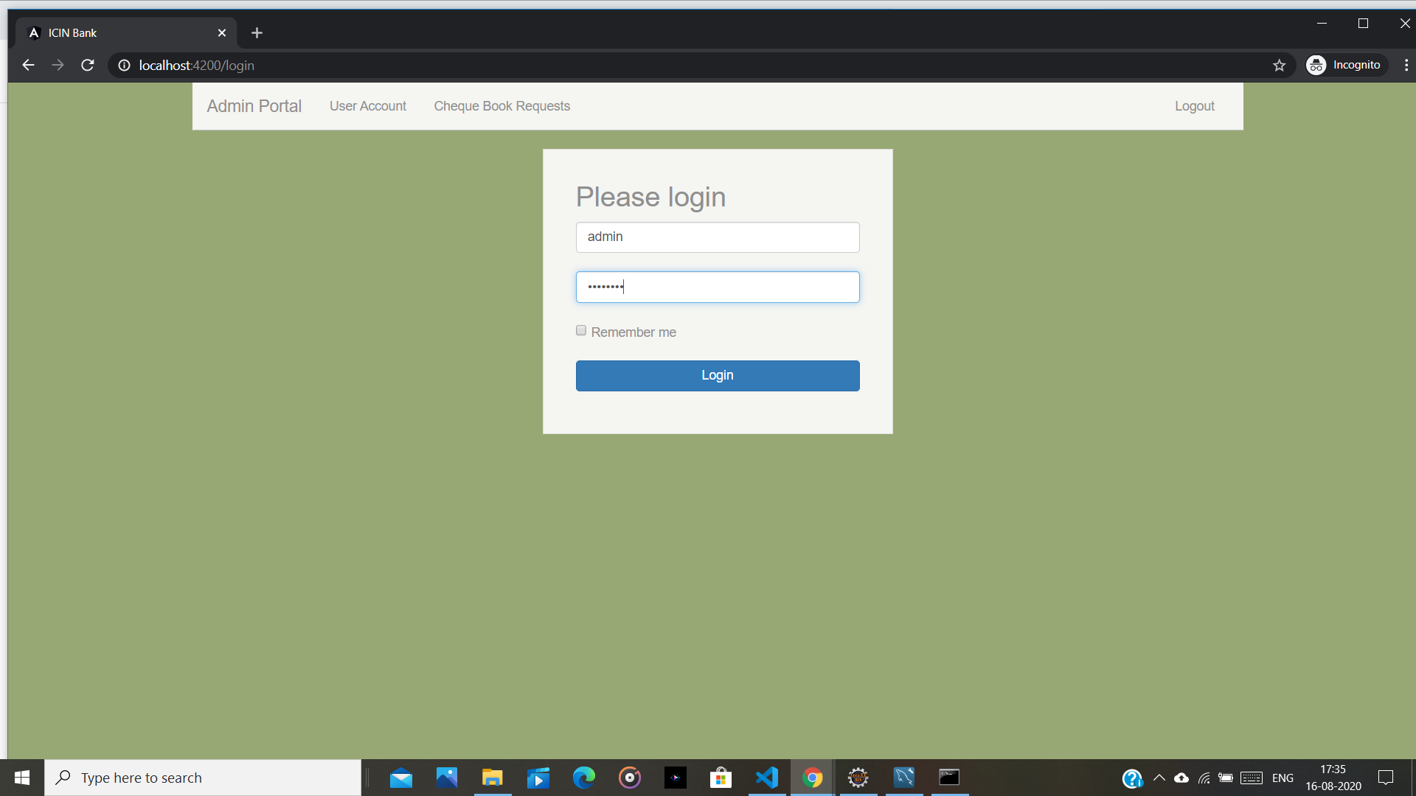

**Admin Home Page:** after the admin has succuessfully logged, the admin homepage will be opened

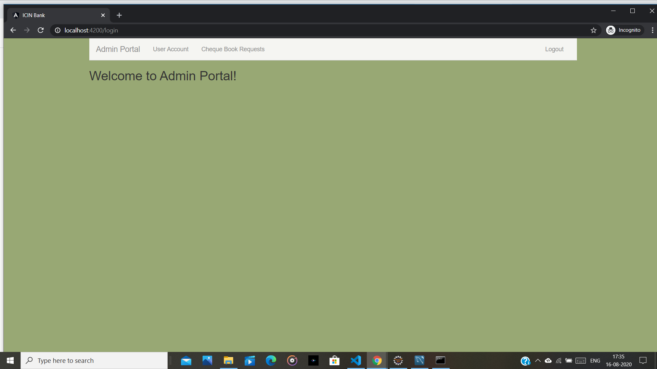

**User Account**: admin can view statements of every Users, confirm an User Request.

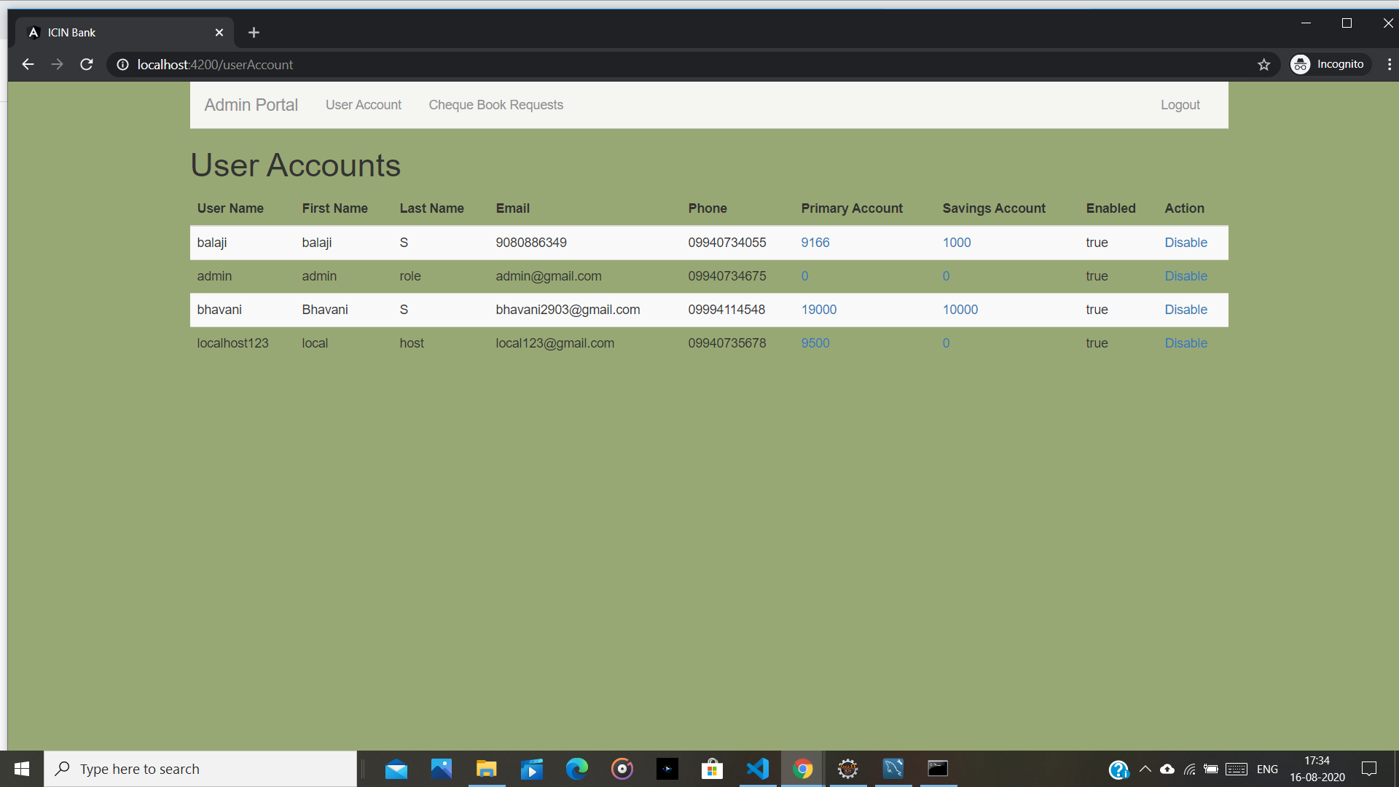

* **Cheque book Request:** confirm the user’s request and also Block a user account in case of any threat and authorize cheque book requests

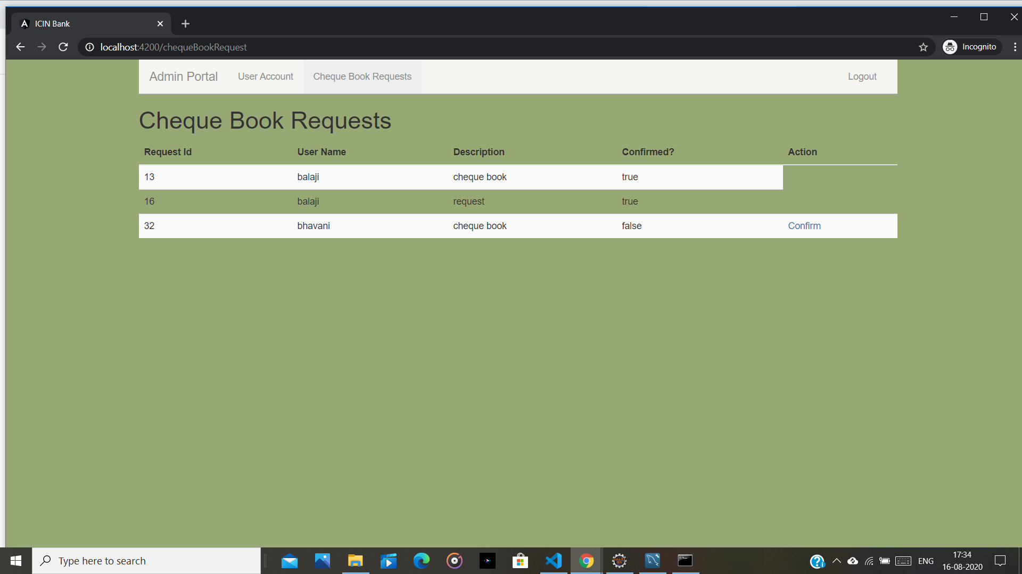

### **PROCESS FLOWCHART**

C:\Ravi\Source\Online Banking System High Level.png

### **CONCLUSION**

Thus, the mentioned task in the problem statement has been excecuted.the source code code has been pushed into the git repository. kindly check the above github link and download the source code. Follow the instruction given in this document.